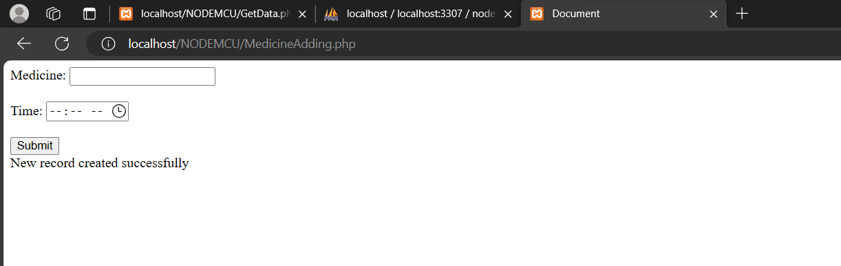

**SAMPLE MEDICINE ADDING THROUGH AN INTERFACE:**

HERE connected to a sql server for adding data into database

**DATABASE:**

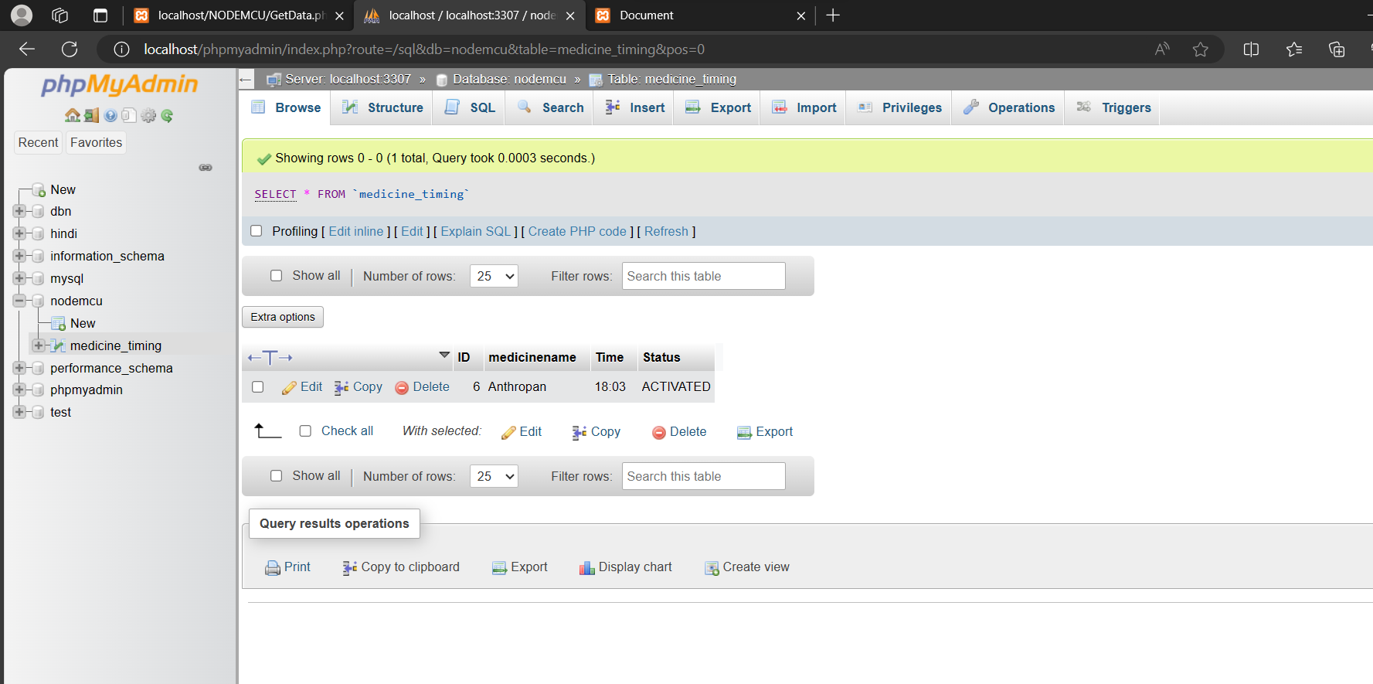

**All the work for sending response to pill dispenser is coded in GetData.php which send response as status 1 or not for particular medicine.**

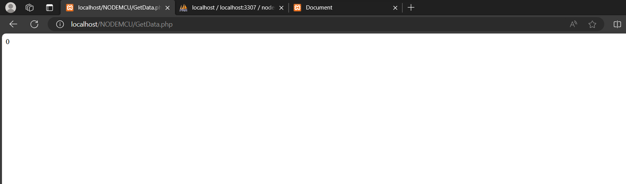

**In above fig we can clearly see the status is 0 or here we can set conveyor belt no so that we can receive response as belt number so it makes easy to deliver pills correctly.**

**How does it work in microcontroller how the code written in it??**

**As we make a request using http for that GetData.php file if status for request is connected then we get a response as data(Belt number) so we manipulate code for moving the belt.**